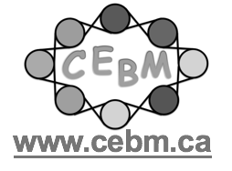
Certificate of Participation

The Child Who Is Resistant
June 15, 2020

1 hour
Eva de Gosztonyi and Catherine Korah
Centre of Excellence for Behaviour Management

