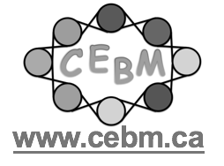
Certificate of Participation

May 5, 2022

1 hour
Eva de Gosztonyi
Centre of Excellence for Behaviour Management
The Neuroscience of Play

