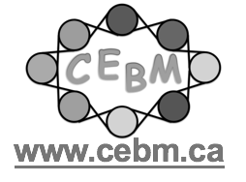
Certificate of Participation

What’s Next? Series:
November 16, 2022
1 hour
Catherine Korah
Centre of Excellence for Behaviour Management
The Child Who is Resistant

